
CSA15 – CLOUD COMPUTING AND BIG DATA ANALYTICS

ASSIGNMENT 1 – CO1
Design, Analyse and Validate a Cloud-Based Solution for Migrating a Legacy University Management System
CO1: Apply cloud computing technologies including hardware–software evolution, virtualization, web services, and service models to develop cloud-based solutions.

Field | Details | Field | Details
Student Name | PINDIBOINA SAI DEEPAK | Register Number | 192411047
Department / Section | CSE | Academic Year / Semester | 2026
Faculty Name | Latha R | Nature of Assignment | Individual
Duration | 1 Week | Total Marks | 50
Submission Date | 31/10/2026 | Evaluation Date

MARK SHEET (Rubric-based evaluation)
Task | Title | Max | Awarded | Evidence / evaluation focus
1 | Introduce Cloud Computing | 3 |  | Definition; characteristics; deployment models; scenario mapping
2 | Trace Evolution and Hardware Evolution | 3 |  | Timeline; hardware evolution; relevance to university
3 | Analyse Internet Software Evolution | 3 |  | Web/software evolution; SOA; APIs; scenario relevance
4 | Apply Server Virtualization | 5 |  | Hypervisor types; VM/container comparison; consolidation; limitations
5 | Apply Web Services | 4 |  | SOA and SOAP/REST; three university APIs; request/response examples
6 | Analyse IaaS, PaaS and SaaS | 5 |  | Responsibility layers; five-application mapping; comparison; providers
7 | Examine XaaS | 3 |  | Four or more variants; two justified choices; provider risks
8 | Design Cloud Solution Architecture | 5 |  | Labelled diagram; deployment/service models; scaling; security; DR
9 | Hands-on Implementation and Documentation | 4 |  | Running VM/container; PaaS/SaaS; tests; actual screenshots
10 | Evaluate and Recommend Final Solution | 7 |  | Three-way comparison; 3-year costs; risks; phased roadmap
11 | Day-4 Design Challenge | 8 |  | Impact; evaluation; adaptation; evidence-based defence
 | TOTAL | 50 |  | Percentage :

EVIDENCE VERIFICATION CHECKLIST

Tasks | Evidence expected | Status (✓ / P / ✗) | Evaluator note
1–3 | Conceptual explanations, comparisons and relevant illustrations | ✓ | Explanations and relevant scenario mapping documented
4 | Virtualization calculations with stated assumptions and peak-load caution | ✓ | Calculations present; practical capacity validation recommended
5–7 | API examples, service responsibility table and justified XaaS choices | ✓ | Required conceptual evidence documented
8 | Labelled architecture diagram, caption below figure and component justification | ✓ | Architecture documented; sizing assumptions need testing
9 | Actual code, environment details, execution logs, API outputs and screenshots | P | Procedures provided; actual execution evidence not established
10 | Cost assumptions, 3-year totals, risk controls and migration roadmap | ✓ | Estimates and rationale documented
11 | Day-4 changes, 10× load strategy, 99.9% target and 40-college isolation | ✓ | Design analysis documented; practical validation pending

IMPLEMENTATION EVIDENCE CHAIN

Evidence item | Status | Observation
Source code | ✓ | Flask REST API and Dockerfile provided in the proposed implementation
Virtualization | P | Docker container configuration documented; running-container evidence required
PaaS or SaaS | P | Managed web-service deployment procedure described; live deployment not verified
Functional test | P | Expected HTTP 200 response and JSON output documented; actual output required
Failure case | P | HTTP 404 test case documented; actual execution record required
Screenshots | P | Screenshot requirements identified; authentic screenshots need verification
Reproducibility | ✓ | Build commands, run commands, endpoints and expected results specified

OVERALL REMARKS

_______________  Student Signature | _______________  Faculty Signature | _______________  Program Director
MANDATORY SUBMISSION EVIDENCE CHECK
✓ = Present in documented answer; P = Partly present; ✗ = Missing / not satisfied
Task | Evidence expected | Status | Evaluator note
1 | Cloud definition, characteristics, deployment models and scenario mapping | ✓ | All conceptual requirements covered
2 | Evolution timeline, hardware development and university relevance | ✓ | Well explained with relevant examples
3 | Internet software evolution, SOA and APIs | ✓ | Clear explanation and scenario relevance
4 | Hypervisors, VM/container comparison and consolidation calculations | ✓ | Calculations included; peak-load limitations discussed
5 | SOAP/REST comparison and three university APIs | ✓ | API methods and request/response examples documented
6 | IaaS/PaaS/SaaS responsibility layers and application mapping | ✓ | All five applications categorized with justification
7 | XaaS variants and two justified selections | ✓ | Six variants explained; DBaaS and DRaaS recommended
8 | Labelled architecture, scaling, security and disaster recovery | ✓ | Design and component justifications documented
9 | Working container, PaaS/SaaS deployment, actual tests and screenshots | P | Code and procedures provided; actual execution evidence requires verification
10 | Three-year cost comparison, risks and migration roadmap | ✓ | Cost assumptions, calculations and recommendations included
11 | Impact analysis, 10× load, 99.9% availability and tenant isolation | ✓ | Changed requirements evaluated; load-test evidence recommended

IMPLEMENTATION EVIDENCE CHAIN
Evidence item | Status | Observation
Source code | ✓ | Python Flask REST API and Dockerfile documented
Virtualization | P | Docker build and run procedures provided; execution screenshot required
PaaS or SaaS | P | Cloud deployment steps described; actual deployment confirmation required
Functional test | P | HTTP 200 and expected JSON response documented; actual test output required
Failure case | P | HTTP 404 test case included; execution evidence required
Screenshots | P | Required screenshots identified but authenticity and completeness not verified
Reproducibility | ✓ | Installation, configuration, commands and testing steps documented
Interpretation | ✓ | Technical outcomes and implementation limitations explained
Code and report consistency | ✓ | Proposed API, Docker configuration and testing procedure are aligned

SUBMISSION CHECKLIST (Not Separately Marked)
Requirement | Status
All 11 tasks answered | ☒ Yes ☐ Partly ☐ No
Cloud concepts and comparisons explained | ☒ Yes ☐ Partly ☐ No
Virtualization calculations included | ☒ Yes ☐ Partly ☐ No
API examples and service models explained | ☒ Yes ☐ Partly ☐ No
Cloud architecture diagram included | ☒ Yes ☐ Partly ☐ No
Implementation and testing evidence provided | ☐ Yes ☒ Partly ☐ No
Three-year cost analysis and roadmap included | ☒ Yes ☐ Partly ☐ No
Day-4 design challenge completed | ☒ Yes ☐ Partly ☐ No
Figures and screenshots included | ☐ Yes ☒ Partly ☐ No
Table and figure numbering correct | ☐ Yes ☒ Partly ☐ No
Viva recommended | ☒ Yes ☐ No

CSA15 – Cloud Computing and Big Data Analytics
ASSIGNMENT 1
CO1: Apply cloud computing technologies including hardware–software evolution, virtualization, web services, and service models to develop cloud-based solutions.

Assignment Title: Design, Analyse and Validate a Cloud-Based Solution for Migrating a Legacy University Management System (Total Marks – 50)
Duration: 1 week
Scenario – Smart Campus Cloud Migration
A multi-campus university currently runs its Student Information System, Learning Management System, Library System, Exam Portal and Email on ageing physical servers in a single on-premise data centre. Each application has its own dedicated server, which stays idle for most of the year but fails to cope during admissions, result publication and online-exam weeks.
The university's current environment is:
- 12 physical servers, average CPU utilisation of about 15%, with peaks above 95% during admissions and exams
- Approximately 25,000 students and 2,000 staff across 4 campuses
- Applications built as large monolithic programs, with no public interfaces for mobile apps or partner colleges
- High capital expenditure, slow procurement (6–8 weeks per server) and no disaster recovery site
As a cloud consultant, you must study how computing evolved to the cloud model, and then design a cloud-based solution that uses virtualization, web services and an appropriate mix of service models (IaaS, PaaS, SaaS and XaaS) for the university. All recommendations must be justified in terms of cost, scalability, availability and manageability.
Design Challenge:
On Day 4, the university announces that it will launch a mobile app and open student-record and fee-payment services to 40 affiliated colleges. Expected load is 10 times the current peak, with a requirement of 99.9% availability and a limited operating budget. Re-evaluate your original design and decide whether it should be retained, modified or redesigned.
TASK 1 – Introduce Cloud Computing and Map It to the Scenario (3 Marks)
Design and Propose cloud computing model for the context of the university's problems.
- Definition of cloud computing and the five essential characteristics (on-demand self-service, broad network access, resource pooling, rapid elasticity, measured service)
- Deployment models (public, private, hybrid, community) and which one suits the university
- Three problems of the current on-premise setup and how each cloud characteristic addresses them
- Benefits and limitations of cloud adoption for the university
Evidence Expected
A clear explanation of cloud characteristics and deployment models, mapped to the university's actual problems.
TASK 2 – Trace the Evolution and Hardware Evolution (3 Marks)
Trace how computing infrastructure evolved to make cloud computing possible.
- A timeline from mainframes, minicomputers and PCs, to client–server, clusters, grid computing, utility computing and cloud
- Hardware evolution: multi-core processors, commodity servers, high-capacity storage, high-speed networking and data centres
- How each stage solved a limitation of the previous one
- Which stage the university's current system corresponds to, with reasons
Evidence Expected
A labelled timeline or diagram, with a justified explanation of how hardware advances enabled the cloud.
TASK 3 – Analyse Internet Software Evolution (3 Marks)
Explain how internet software evolved and why it supports cloud services.
- Evolution from static web pages to dynamic web, Web 2.0, SOA, mashups and cloud-hosted applications
- Role of browsers, HTTP, AJAX and APIs in delivering software over the internet
- Comparison between desktop software, client–server software and web-delivered software
- How this evolution affects the design of the university's applications
Evidence Expected
A comparative explanation of software evolution stages, linked to the university's application design.
TASK 4 – Apply Server Virtualization (5 Marks)
Apply server virtualization to consolidate the university's 12 physical servers.
- Explain how a hypervisor works, and distinguish Type-1 and Type-2 hypervisors, with examples
- Compare full virtualization, para-virtualization, OS-level virtualization (containers) and hardware-assisted virtualization
- Propose which applications should run as virtual machines and which as containers, with reasons
- Calculate the consolidation: with an average utilisation of 15% per server and a target host utilisation of 70%, estimate how many physical hosts are needed (show your assumptions and working)
- Discuss live migration, snapshots and resource over-commitment as benefits, and the risks of virtualization (noisy neighbour, hypervisor failure, security isolation)
Show your calculation. A final number without working will not receive full credit.
Evidence Expected
A justified virtualization plan with a worked consolidation calculation and discussion of benefits and risks.
TASK 5 – Apply Web Services (4 Marks)
Analyse web services to expose the university's functions to other systems.
- Overview of web services and their role in cloud and SOA
- Compare SOAP, WSDL, UDDI and RESTful services (HTTP methods, JSON/XML)
- Identify at least three university functions to expose as web services (for example, result lookup, fee payment, library search) and define the endpoint, method and sample request/response for each
- Justify whether SOAP or REST is more suitable for each function
Evidence Expected
A defined set of web services with sample request/response formats and a justified choice of SOAP or REST
TASK 6 – Analyse the Service Models: IaaS, PaaS and SaaS (5 Marks)
Analyse which service model fits each university application.
- Define IaaS, PaaS and SaaS, and show who manages which layer (hardware to application) in each model
- Categorise the five university applications (SIS, LMS, Library, Exam Portal, Email) into IaaS, PaaS or SaaS, with reasons
- Compare the models on control, cost, scalability, maintenance effort and vendor lock-in
- Give one real provider example for each model
Present your categorisation in a table, but explain the reasoning behind each decision. A table alone is not sufficient.
Evidence Expected
A reasoned mapping of applications to service models, supported by a layer-wise responsibility comparison.
TASK 7 – Examine XaaS (3 Marks)
Examine the broader XaaS (Anything-as-a-Service) concept for the university.
- Explain XaaS and describe at least four variants (for example DaaS, BaaS/MBaaS, FaaS, DBaaS, Security-as-a-Service, Disaster-Recovery-as-a-Service)
- Select two XaaS offerings that would benefit the university, and justify them
- Discuss the risks of over-reliance on multiple 'as-a-Service' providers
Evidence Expected
An analysis of XaaS variants, with justified selection of two offerings for the university.
TASK 8 – Design the Cloud Solution Architecture (5 Marks)
Bloom's Level: Level 6 – Create | Action verbs: Design, Construct, Propose
Create a complete cloud architecture for the university by combining virtualization, web services and service models.
- An architecture diagram showing users, load balancer, web/application tier, database tier, storage, API layer and DR region
- The deployment model and the service model chosen for each component
- How elasticity (auto-scaling) will handle admissions and exam peaks
- Basic security and availability measures (access control, encryption, backup, multi-zone deployment)
Evidence Expected
A labelled architecture diagram with written justification for each component and design decision.
TASK 9 – Hands-on Implementation and Documentation (4 Marks)
Implement a small proof-of-concept of your design using a free-tier cloud account or a local virtualization tool.
- Create a virtual machine or container (using AWS/Azure/GCP free tier, VirtualBox, or Docker) and host a simple web page or REST API for one university function
- Deploy a SaaS or PaaS component (for example a cloud-hosted database, a serverless function or a static site)
- Test the web service with a client (browser, Postman or curl) and record the output
- Provide screenshots, configuration steps and any issues faced
Evidence Expected
Annotated screenshots and clear, reproducible steps showing that the proof-of-concept works.
TASK 10 – Evaluate and Recommend the Final Solution (7 Marks)
Evaluate your design and recommend the final cloud solution for the university.
- Compare on-premise, IaaS-based and PaaS/SaaS-based options on cost (CapEx vs OpEx), scalability, availability, security and effort
- Estimate a simple 3-year cost comparison using stated assumptions
- Identify the main risks (vendor lock-in, data privacy, downtime, skills gap) and give mitigation steps
- Provide your final recommendation and a short migration roadmap (which application moves first, and why)
Your recommendation must be supported by the analysis in the previous tasks. Choosing a popular cloud provider without justification is not sufficient.
Evidence Expected
A technically justified recommendation, supported by a cost comparison, risk analysis and migration roadmap.
DAY-4 DESIGN CHALLENGE
TASK 11 – Re-evaluate and Adapt the Design (8 Marks)
Changed Requirement
The university will now launch a mobile app and open student-record and fee-payment services to 40 affiliated colleges. Expected load is 10 times the current peak, availability must be 99.9%, and the operating budget is limited.
Re-evaluate your original design in response to these changed conditions. You may:
RETAIN → MODIFY → or REDESIGN
your original solution.
Impact Analysis – 2 Marks
Discuss:
- What has changed from the original problem
- Which original assumptions (load, users, availability, cost) are affected
- Why the web services and APIs now become critical
- How multi-tenant access by 40 colleges affects security and isolation
Evidence Expected: A clear analysis of how the changed requirements affect the original cloud design.
Evaluation of the Original Design – 2 Marks
Discuss:
- Whether the chosen service models and virtualization plan can handle a 10x load
- Whether auto-scaling and the single-region deployment are sufficient for 99.9% availability (about 8.76 hours of downtime allowed per year)
- Whether cost remains acceptable under the new load
- Whether another service model or XaaS offering would give better overall results
Evidence Expected: A technically supported evaluation of the original design under the new conditions.
Adaptation or Redesign – 2 Marks
Discuss:
- Decide whether to retain, modify or redesign the solution
- Describe the revised architecture (for example API gateway, container orchestration, serverless components, multi-zone deployment or a hybrid model)
- Explain what changed in the service model mix and in the virtualization approach
- If you retain the original design, give sufficient technical justification for why no change is required
Evidence Expected: An appropriate design response to the changed requirement, with clear technical reasoning.
Evidence-Based Defence – 2 Marks
Discuss:
- Capacity and availability calculations
- Cost comparison between the original and the revised design
- Security and multi-tenancy considerations
- Trade-offs such as vendor lock-in, complexity and migration effort
Evidence Expected: A well-supported final decision that follows logically from the analysis.
MARK DISTRIBUTION
Task | Title | Bloom's Level | Marks
Task 1 | Cloud Computing – Introduction & Characteristics | L2 – Understand | 3
Task 2 | Evolution & Hardware Evolution | L2 – Understand | 3
Task 3 | Internet Software Evolution | L2 – Understand | 3
Task 4 | Server Virtualization | L3 – Apply | 5
Task 5 | Web Services | L3 – Apply | 4
Task 6 | Service Models: IaaS, PaaS, SaaS | L4 – Analyze | 5
Task 7 | XaaS | L4 – Analyze | 3
Task 8 | Design the Cloud Solution Architecture | L6 – Create | 5
Task 9 | Hands-on Implementation & Documentation | L3 – Apply | 4
Task 10 | Evaluate & Recommend the Final Solution | L5 – Evaluate | 7
 | Subtotal

Task 11 | Day-4 Design Challenge | L4 / L5 / L6 | 8
 | TOTAL |  | 50

Task 1 — Introduce Cloud Computing and Map It to the University
1.1. Cloud computing
Cloud computing provides network access to a shared pool of computing resources—such as servers, storage, networks and applications—that can be provisioned and released quickly with little manual effort. The university can use these resources when needed instead of buying and maintaining enough physical servers for its busiest weeks.
1.2. The five essential characteristics
Characteristic | What it means | How it addresses the university’s needs
On-demand self-service | Users can provision resources automatically when needed, without waiting for the provider to configure each request. | The IT team can create a test server or add storage without waiting 6–8 weeks for new hardware procurement.
Broad network access | Services are available over a network through standard devices and interfaces. | Students and staff across four campuses can access systems through browsers and mobile devices.
Resource pooling | A provider shares a pool of computing resources among customers, assigning capacity as demand changes. | The university can draw on shared cloud capacity instead of keeping 12 lightly used dedicated servers.
Rapid elasticity | Capacity can expand or shrink quickly as demand changes. | The university can add capacity during admissions, result publication and exams, then reduce it during quieter periods.
Measured service | Resource use is monitored and measured, supporting control and reporting of consumption. | IT can track usage by service and campus, set budgets and investigate unexpected demand. Usage-based billing also makes costs more visible, though it requires monitoring.

1.3. Cloud deployment models
A deployment model describes who can use the cloud infrastructure and how it is operated.
- Public cloud: A cloud provider operates shared infrastructure for multiple customers. It offers broad access and flexible capacity, but the university must carefully configure security and control costs.
- Private cloud: Infrastructure is dedicated to one organization. It offers more direct control, but the university may still carry significant management and capacity costs.
- Community cloud: Infrastructure is shared by organizations with common needs, such as a group of universities. It may support shared governance, but requires participating institutions to agree on costs, access and management.
- Hybrid cloud: Two or more distinct cloud infrastructures—such as private and public clouds—are connected so that data or applications can move between them. It can combine dedicated control with public-cloud flexibility, but brings integration and management complexity.
Recommended model: hybrid cloud, with a public-cloud emphasis. Use public-cloud capacity for routine services and workloads that need to scale, while retaining a connected private environment for university data or systems that require tighter control. This is a practical starting recommendation: the assignment does not specify legal or institutional rules requiring particular records to stay on premises. The university should classify its data and confirm those requirements before deciding what belongs in each environment.
A hybrid model does not automatically make data safer or guarantee availability. The university still needs access controls, encryption, backups, monitoring and a tested recovery plan.
1.4. Three current problems and how cloud characteristics help
- Servers sit idle most of the year but struggle during peaks.
With average CPU utilisation around 15%, dedicated servers leave much of their capacity unused, while exam and admissions peaks exceed 95%. Resource pooling can reduce the need to reserve a separate server for every application; rapid elasticity can add capacity during peak periods and release it later.
- New capacity is slow and expensive to procure.
Waiting 6–8 weeks for each physical server makes it difficult to respond to changing needs. On-demand self-service allows IT staff to request capacity quickly, while measured service helps the university see what it uses and manage spending.
- Systems are difficult to access and extend.
The current monolithic applications lack public interfaces for mobile apps and partner colleges. Broad network access supports access from different campuses and devices. Cloud hosting can also provide a network-accessible foundation for future integrations; the university would still need to develop or modernise the application interfaces to expose those functions safely.
1.5. Proposed high-level architecture
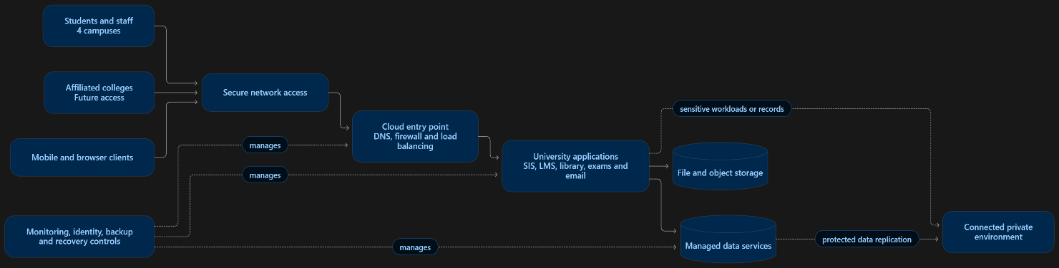
Figure 1. A hybrid-cloud concept for the university. The diagram is a proposed high-level design; exact data placement depends on the university’s security, policy and regulatory requirements.
1.6. Benefits and limitations
Likely benefits: The university can provision capacity more quickly, scale around academic peaks, reduce dependence on dedicated underused servers and give users across campuses broader access. Measured usage can also help the IT team understand demand and budget for services.
Limitations to plan for: Cloud charges can grow if resources are left running or usage is poorly monitored. The university depends on reliable network connectivity and provider services. Moving legacy monolithic applications may require redesign or integration work, and a hybrid environment can add operational complexity. Security and availability also require active configuration and management; adopting cloud services alone does not guarantee either.
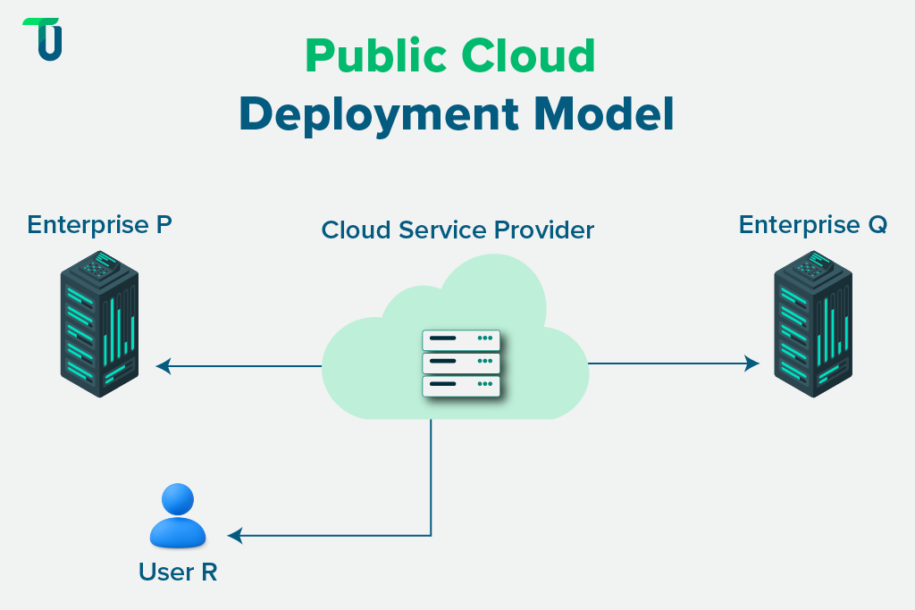
Task 2 — Trace the Evolution of Computing and Hardware
Computing evolved from large, centralized machines into connected systems that can provide resources on demand. Each stage addressed limits in cost, access, processing power or resource sharing. Improvements in processors, storage, networking and data centres made it practical to operate cloud services at scale.
  - Computing infrastructure timeline
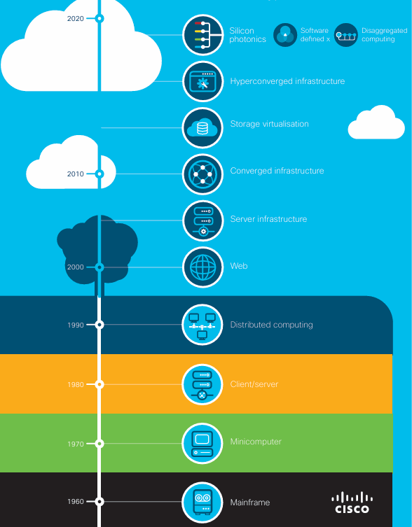
Figure 2.1. A simplified timeline of the infrastructure that led to cloud computing.
Stage | What it introduced | Limitation addressed | Remaining limitation
Mainframes | A powerful central computer served many users through terminals. | Replaced separate, limited machines with centrally managed processing and data. | Mainframes were expensive, centrally controlled and often tied to a single site or vendor.
Minicomputers | Smaller systems made computing available to departments and mid-sized organisations. | Reduced the cost and scale barrier of mainframe computing. | Systems were still managed separately and had limited capacity compared with later networks.
Personal computers | Individuals could run software locally on their own machines. | Gave users direct access to computing without competing for a central system. | Data and applications became scattered across many devices, making sharing and central management harder.
Client–server computing | Networked client devices requested data or services from central servers. | Enabled shared databases and applications across an organisation. | Servers could become bottlenecks or single points of failure, and capacity planning remained manual.
Clusters | Multiple connected computers worked together as one system or service. | Improved processing capacity and availability beyond a single server. | Clusters were commonly built and managed for a specific organisation or workload.
Grid computing | Distributed resources across locations or organisations were coordinated for large tasks. | Allowed larger workloads to use resources beyond one computer or site. | Coordinating different systems and managing shared access could be complex.
Utility computing | Computing capacity was treated as a service that could be metered and charged by use. | Introduced a more flexible alternative to purchasing all capacity upfront. | Providers still needed a practical way to provision, pool and scale resources efficiently.
Cloud computing | Network-accessible pooled resources can be provisioned, scaled and measured on demand. | Combines shared infrastructure, automated provisioning, broad network access and measured use. | It introduces dependencies on providers, connectivity, security configuration and cost management.
2.2. Hardware advances that enabled cloud computing
- Multi-core processors: A single server can run multiple tasks at once. This supports many virtual machines and services on shared hardware.
- Commodity servers: Standardised, relatively affordable servers made it practical for providers to build large pools of computing capacity from many machines.
- High-capacity storage: Larger and more reliable storage systems can hold application data, backups and files for many customers.
- High-speed networking: Faster connections between servers and data centres allow applications to communicate, move data and serve users across campuses and regions.
- Large, professionally managed data centres: Purpose-built facilities combine power, cooling, physical security, networking and many servers. Providers can manage capacity centrally and offer it to customers over the internet.
- Virtualisation support: Modern processors and related hardware features help run multiple isolated virtual machines on one physical server, improving flexibility and utilization.
2.3. Where the university’s current system fits
The university’s 12 dedicated physical servers represent a traditional on-premise server environment. Its applications use a client–server pattern in the broad sense—users access centrally hosted systems—but the servers are assigned to separate applications and are not described as a pooled, elastic cloud environment.
The scenario’s figures show the capacity problem: average CPU use is about 15%, yet peak demand rises above 95% during admissions and exams. This means the university has idle capacity much of the year but still struggles to meet short-lived peaks. Slow procurement and the lack of a disaster recovery site further limit its ability to respond.
A cloud migration would move the university toward pooled, network-accessible infrastructure that can be provisioned more quickly and scaled as demand changes. It would still need to assess whether each legacy application can move as-is or requires modification; cloud infrastructure does not automatically modernise monolithic software.
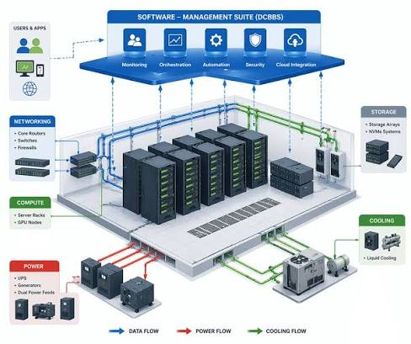

Task 3 — Analyse Internet Software Evolution
3.1 How internet software evolved
Internet software developed from pages that mainly displayed information into interactive, connected applications. This change made it possible for universities to deliver services through a browser and connect those services to mobile apps and partner systems.
Stage | What changed | University example
Static web pages | Pages contain mostly fixed text and images. A server sends the page to the browser; users mainly read it. | A university website listing campus addresses or course descriptions.
Dynamic web | Pages are generated using server-side programs and databases. Content can vary by user or request. | A student signs in and sees their own timetable or exam results.
Web 2.0 | Web applications became more interactive, with user input, updates and collaboration. Technologies such as JavaScript and AJAX helped refresh parts of a page without reloading the whole page. | Students register for courses, update profiles or participate in LMS discussions.
Service-Oriented Architecture (SOA) | Application functions are exposed as services that other applications can call through agreed interfaces. | The student information system provides student identity or enrolment information to the LMS.
Mashups and API-based applications | Developers combine services and data from different systems through APIs to create new user experiences. | A student portal combines course information, a campus map and library availability.
Cloud-hosted applications | Applications run on provider-managed infrastructure and can be accessed over the internet. Capacity can be adjusted as demand changes. | The university hosts its portal in the cloud and scales it during admissions or result publication.
This progression does not mean that every older application automatically becomes a modern web application. A legacy monolithic system may need an interface layer, updates to its code, or gradual replacement before mobile apps and partner colleges can use its data safely.
3.2 The role of browsers, HTTP, AJAX and APIs
A browser is the user’s interface to a web application. It displays pages, runs client-side code and sends requests to the application server. Students and staff can therefore use university services from different devices without installing a separate desktop program for every service.
HTTP and HTTPS carry requests and responses between a browser, mobile app or other client and a web server. HTTPS encrypts communication in transit, which is essential when users access personal information or submit payment details. The university must still secure the application and data themselves.
AJAX allows a web page to request information in the background and update part of the screen without reloading the entire page. For example, the student portal could refresh a course list after a student selects a semester.
An API defines how one software system requests a function or data from another. APIs can let a mobile app or affiliated college request permitted services—such as course information or a fee-payment operation—without giving that client direct access to the university’s internal database. The university should authenticate API users, limit the data each client can access and record requests for auditing.
3.3 Desktop, client–server and web-delivered software
Aspect | Desktop software | Client–server software | Web-delivered software
Where it runs | Installed and runs mainly on each user’s computer. | The client runs on a user’s device and communicates with a central server. | The user accesses the application through a browser or mobile interface; application logic runs on web or cloud servers.
Updates | Often need to be installed on each device. | Client and server components may both need updates. | Server-side updates can be deployed centrally; browser clients usually need fewer manual updates.
Access | Often tied to a particular device or operating system. | Available to connected users, depending on the client software and network. | Can be accessed across compatible devices using a network connection and browser or app.
Scaling and maintenance | The organisation manages many installations and user devices. | The organisation manages clients, servers and their connections. | The provider or university team manages the web environment; capacity can be scaled if the hosting design supports it.
University example | A locally installed examination-processing program. | A campus application installed on staff computers and connected to a central database. | A student portal used through a browser or mobile app.
Web-delivered software can simplify access for students across four campuses and make central updates easier. It also creates dependencies on network availability, secure identity management and well-maintained server infrastructure.
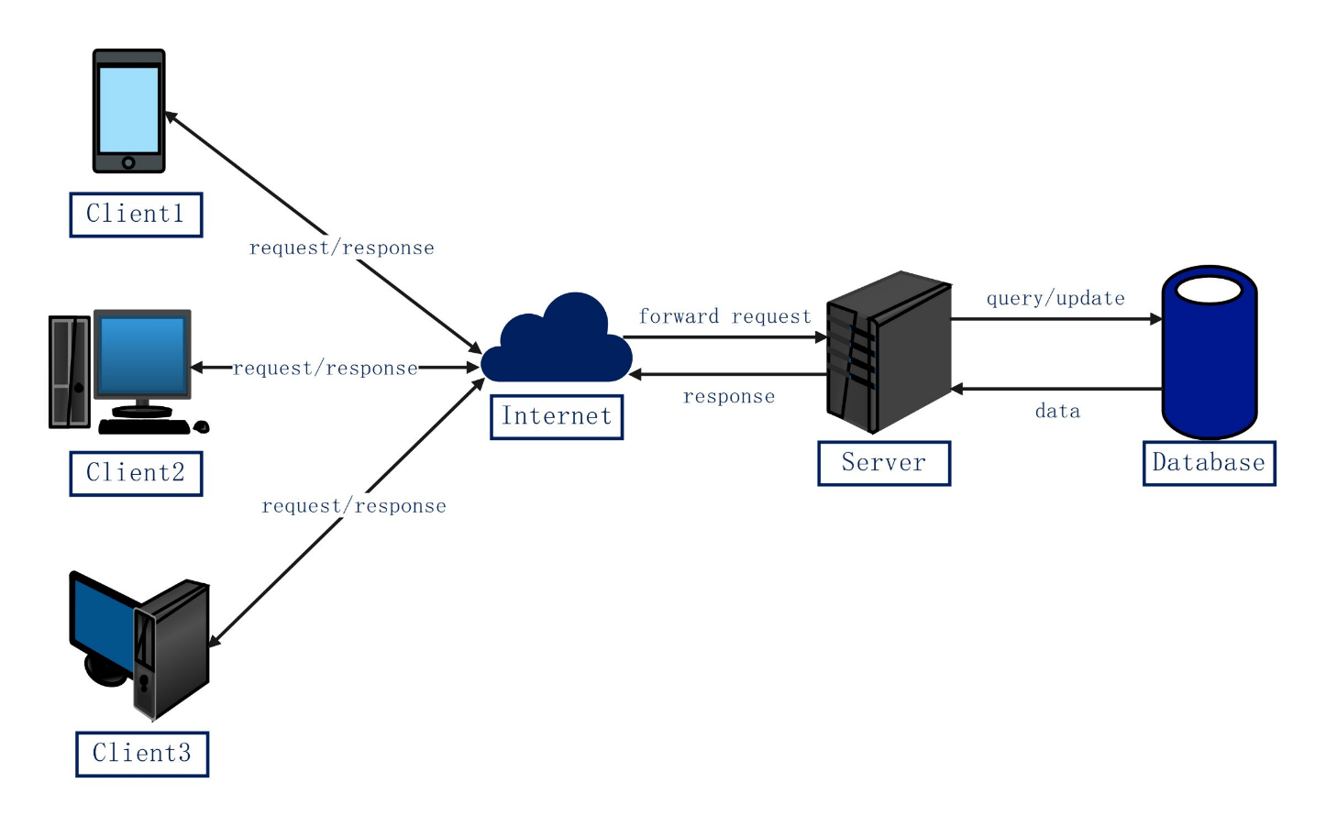
3.4 Implications for the university’s application design
The university’s monolithic applications were built as large programs and currently lack public interfaces for mobile apps or partner colleges. A suitable modernization approach is to keep core functions working while introducing secure web interfaces around them.
For example, the university could provide a student portal and mobile app that communicate with a protected application layer. That layer can validate user identity, check permissions and send approved requests to existing systems. Over time, the university can separate functions that need independent scaling or updates, while avoiding a risky all-at-once rewrite.
The APIs should expose only the functions each user needs. Students might access their own results; staff could have wider administrative access; affiliated colleges should only access records and fee services that the university has authorised for them. This design supports new channels while protecting the underlying records.

Task 4 — Apply Server Virtualization
4.1 Proposed virtualization approach
The university currently assigns 12 physical servers to its applications. Because average CPU utilisation is only about 15%, much of that hardware is idle during ordinary periods. Server virtualization lets one physical server run several separate virtual servers, called virtual machines (VMs). Each VM can run its own operating system and application while sharing the host’s processor, memory and storage.
A hypervisor is the software layer that creates and manages VMs. It allocates hardware resources to each VM and keeps their operating systems separate. A VM might run the university’s existing Student Information System (SIS) while another runs the library application.
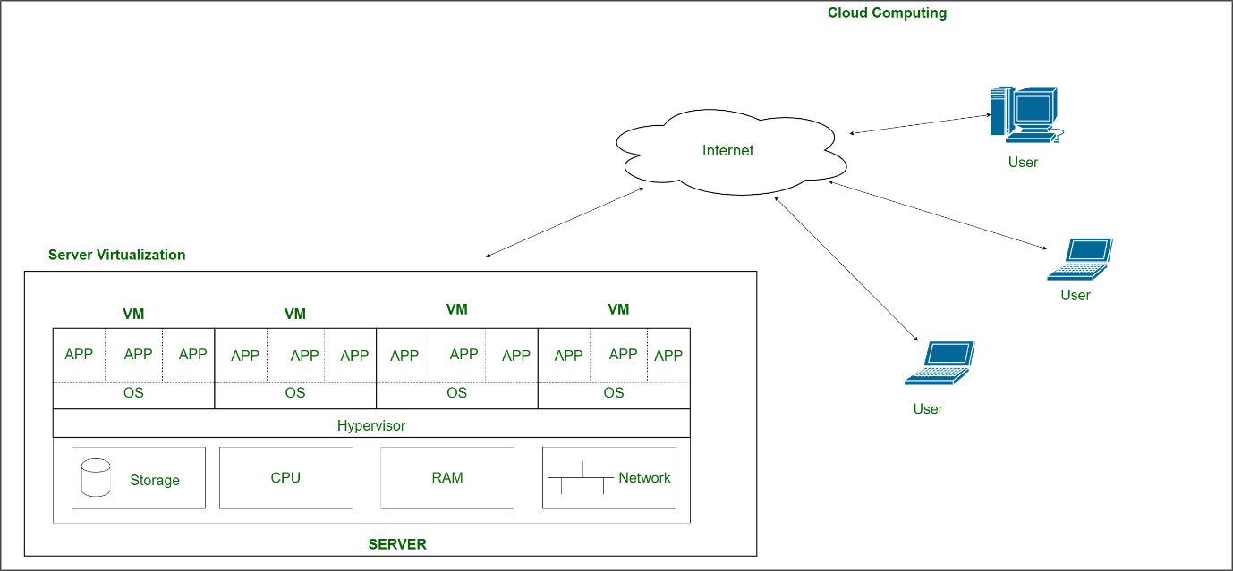
4.2 Hypervisor types
Type 1 hypervisors run directly on physical server hardware. They are commonly used in data centres because they avoid a general-purpose desktop operating system between the hypervisor and the hardware. Examples include VMware ESXi, Microsoft Hyper-V and Xen.
Type 2 hypervisors run as applications on top of a host operating system, such as Windows or macOS. They are useful for desktop development and testing. Examples include Oracle VirtualBox and VMware Workstation.
For production university workloads, a Type 1 hypervisor is the better fit. It is designed for central server management and can support multiple VMs on each host.

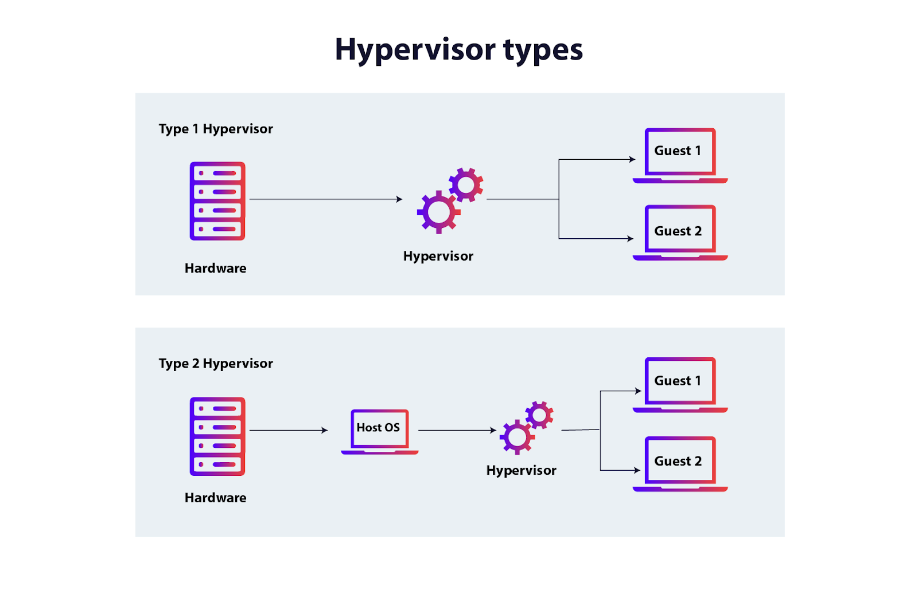
4.3 Full, para- and hardware-assisted virtualization
- Full virtualization: The hypervisor presents virtual hardware to a guest operating system, which can usually run without modification. This suits the university’s existing applications if they depend on a particular operating system.
- Para-virtualization: The guest operating system is modified or uses special interfaces to cooperate with the hypervisor. This can improve efficiency in some cases, but may require changes that are impractical for legacy systems.
- Hardware-assisted virtualization: Processor features, such as Intel VT-x or AMD-V, help the hypervisor run guest operating systems efficiently. This is widely used to support modern VMs.
- OS-level virtualization (containers): Containers isolate applications while sharing the host operating system’s kernel. They usually start quickly and use fewer resources than full VMs, but they do not provide each application with its own separate guest operating system.
4.4 Which workloads should use VMs or containers?
VMs are a sensible first step for legacy university systems such as the SIS, exam portal and library system. These applications may require specific operating systems, libraries or configurations. Moving them into VMs can consolidate hardware while preserving much of their existing environment.
Containers suit applications that are designed or updated as smaller services, such as a new student portal or API layer. Containers can be deployed and scaled independently when their software and operating-system requirements allow it.
The university should assess each application before choosing. A monolithic application may not gain much from being put into containers if it cannot be separated into independently deployable parts.
4.5 Worked server-consolidation estimate
Assumptions: All 12 current servers have roughly equal CPU capacity. The 15% average CPU utilisation is treated as an average across the servers. New hosts are assumed to have comparable usable CPU capacity, and the calculation covers average CPU demand only.
Current average CPU demand, expressed in equivalent fully utilised servers:
12 servers × 15% = 1.8 server-equivalents
At a target host utilisation of 70%, the number of hosts required is:
1.8 ÷ 0.70 = 2.57
Round up to a whole host:
Estimated minimum: 3 physical hosts
This is a baseline estimate, not a guarantee that three hosts can handle admissions or exam peaks. The assignment says CPU peaks exceed 95%, but does not specify how long they last or how many servers reach that level at once. The university should measure peak CPU, memory, storage and network demand before selecting host sizes.
For resilience, three hosts may also be tight. If one host fails, the other two would need to carry the workloads. Using the average demand above, that would be 1.8 ÷ 2 = 90% average CPU utilisation across the remaining hosts, above the 70% target. A four-host design would leave three hosts after one failure, giving 1.8 ÷ 3 = 60% average utilisation under the same assumptions. Peak-demand testing is still necessary.
4.6 Benefits and risks for the university
Virtualization can reduce the number of physical servers, improve average hardware use and make it easier to create or restore server environments. Live migration can move a running VM between compatible hosts for maintenance, provided the infrastructure supports it. Snapshots can help capture a VM’s state before a change, but they are not a substitute for backups. Resource over-commitment allows the university to allocate more virtual CPU or memory than the physical host has, but excessive over-commitment can cause slowdowns when workloads compete for resources.
Virtualization also creates shared risks. A noisy neighbour occurs when one VM consumes so much CPU, memory or storage that others slow down. A host or hypervisor failure can affect several applications at once. Poorly configured isolation or management access can create security risks. The university should monitor resource use, patch and restrict hypervisor management access, keep tested backups, and plan enough spare capacity to handle maintenance or host failure.

Task 5 — Apply Web Services
5.1 Web services in the university system
A web service lets one software system request a function or data from another system through a defined network interface. The university could use web services to connect its Student Information System (SIS), fee system, library, mobile app and affiliated colleges without giving each client direct access to internal databases.
This fits Service-Oriented Architecture (SOA): application functions are exposed as services that other authorised systems can call. A mobile app might request a student’s results from the SIS service; the SIS checks the request and returns only the permitted information.
5.2 Proposed service architecture
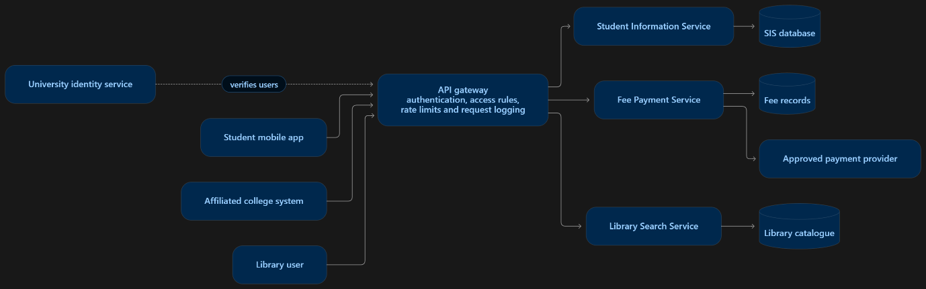
Figure 5.1. Web services place a controlled API layer between client applications and university systems. The gateway can authenticate callers, enforce access rules and log requests; each service remains responsible for its own data and business rules.
5.3 SOAP, WSDL, UDDI and REST
SOAP is a messaging protocol that structures requests and responses as XML envelopes. It supports formal service contracts and can be suitable when systems require strict message formats or established enterprise integrations.
WSDL (Web Services Description Language) describes a SOAP service’s operations, message formats and network address. A client can use the WSDL contract to understand how to call the service.
UDDI (Universal Description, Discovery and Integration) is a registry concept for publishing and discovering web services. It is less central in many modern application designs, where APIs are commonly documented through direct developer portals or specifications.
REST is an architectural style commonly used with HTTP. A REST API represents resources through URLs and uses HTTP methods such as GET to retrieve data, POST to create or submit data, PUT or PATCH to update it, and DELETE to remove it. REST APIs often exchange JSON because it is compact and widely supported, though XML can also be used.
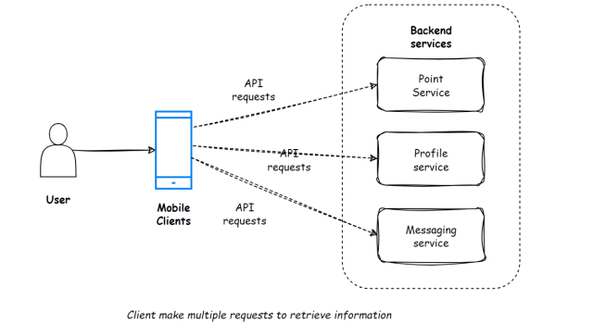
5.4 University service examples
The endpoints below are illustrative. In a real system, each request would also need authentication, authorisation, input validation and secure transport over HTTPS. Student identifiers and payment details should not be exposed in public URLs or logs.
Service and API | Request → response | Choice
Results  GET /api/v1/students/{id}/results?semester=2026S1 | Request: student ID and semester. Response: {"course":"CSA15","grade":"A"} | REST — retrieves a specific student’s results.
Fee payment POST /api/v1/payments | Request: {"invoiceId":"INV8452","amount":12500} Response: {"paymentId":"P9021","status":"pending"} | REST — lets the app submit a payment request and receive its status.
Library search GET /api/v1/library/items?q=cloud | Request: search term. Response: {"title":"Cloud Computing","available":true} | REST — suits read-only searches from apps and portals.
The examples use JSON to make requests and responses readable. The actual service should return appropriate HTTP status codes—for example, success for a valid lookup, an authentication error for an unauthorised request, or a not-found response when a record does not exist.
For these three services, REST is a practical default because the clients include mobile apps and partner systems, and the functions map naturally to resources and HTTP methods. SOAP could still be appropriate if an existing university or payment integration requires a formal WSDL contract or SOAP-specific enterprise features.

Task 6 — Analyse the Service Models: IaaS, PaaS and SaaS
6.1 What the service models provide
Cloud service models describe how much of the computing environment the provider manages.
Infrastructure as a Service (IaaS) provides virtual machines, networks and storage. The provider manages the physical data centre and hardware; the university manages operating systems, applications, data and much of the security configuration.
Platform as a Service (PaaS) provides a managed application platform. The provider manages infrastructure, operating systems and runtime; the university focuses on its application code and data.
Software as a Service (SaaS) provides a complete application over the internet. The provider manages the application and underlying platform; the university manages user access, configuration and its use of the service.
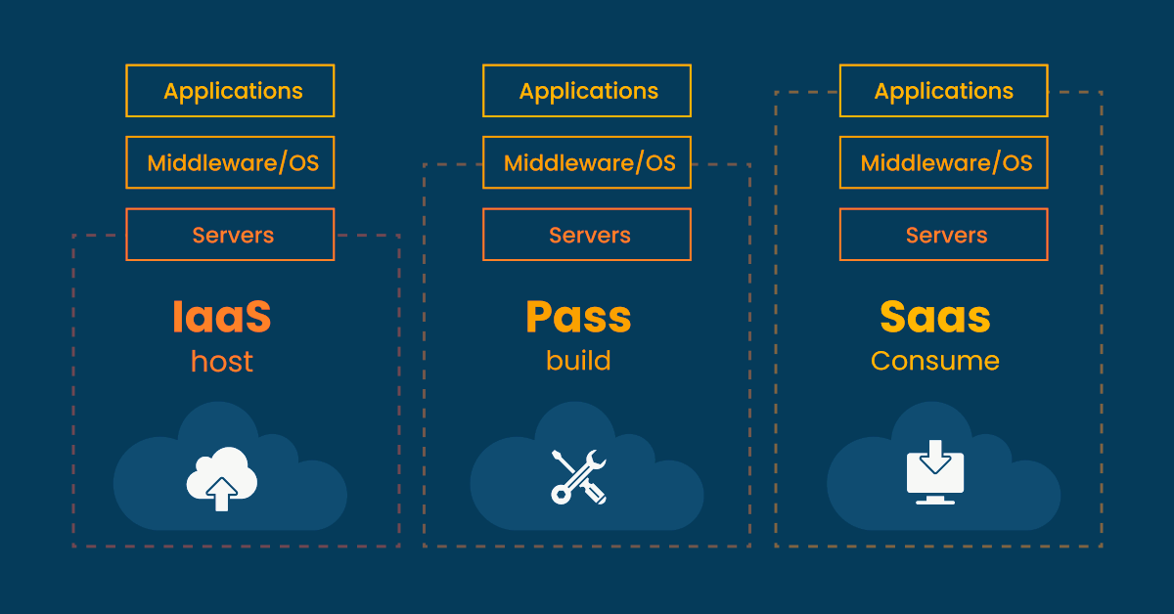
6.2 Service model choices for the university
Application | Suggested model | Reason
Student Information System (SIS) | IaaS initially; consider PaaS after modernisation | A legacy SIS may need a specific operating system or database. A VM can preserve that environment during migration.
Learning Management System (LMS) | SaaS | A mature LMS can be provided as a complete service, reducing the university’s patching and infrastructure work.
Library system | SaaS or PaaS | A suitable library product may be available as SaaS. If the university needs custom integrations, PaaS may suit the integration layer.
Exam portal | PaaS or IaaS | A modern exam application can use PaaS for managed scaling. A legacy portal may first need IaaS to preserve its existing environment.
Email | SaaS | Email is a common, fully managed service and does not usually require the university to maintain mail servers.
These are starting recommendations; product compatibility, data handling requirements, migration effort and contract terms should be checked before selection.
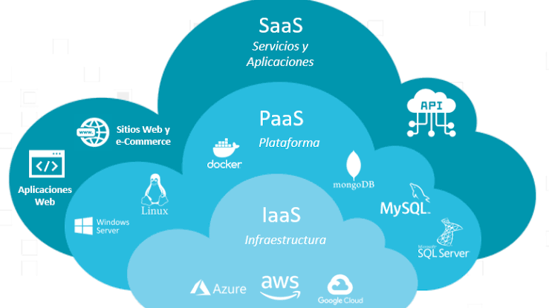
6.3 Responsibility and trade-offs
As the university moves from IaaS to PaaS to SaaS, the provider takes responsibility for more of the technology stack. This usually reduces the university’s maintenance work, but also reduces its control over underlying systems. IaaS offers the most control and can suit legacy workloads, but requires the university to patch and manage more components. PaaS reduces platform operations, while SaaS shifts most application operations to the provider. All models still require the university to manage identities, permissions, data handling and appropriate security settings.
Provider examples: Amazon EC2, Microsoft Azure Virtual Machines and Google Compute Engine are IaaS offerings; Azure App Service, Google App Engine and AWS Elastic Beanstalk are PaaS offerings; Microsoft 365 and Google Workspace are SaaS offerings. Confirm provider capabilities and contract terms when choosing a product

Task 7 — Examine XaaS
7.1 Meaning of XaaS
XaaS, or “Anything as a Service,” describes technology capabilities delivered over a network as services. The university subscribes to the capability it needs and configures how to use it, while the provider operates some or most of the underlying technology. The amount of provider management depends on the specific service.
XaaS can reduce the need to buy, install and maintain separate systems. It can also create new dependencies: the university must understand what the provider manages, what it remains responsible for, how data is protected, and how to move its data if it changes providers.
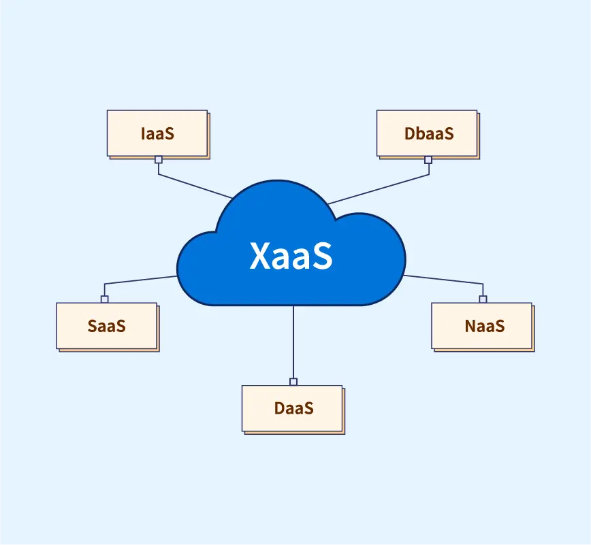
7.2 XaaS options relevant to the university
- Database as a Service (DBaaS): A provider operates the database platform, including tasks such as patching and monitoring. The university still designs its data structure, sets access permissions and checks backup and recovery arrangements.
- Disaster Recovery as a Service (DRaaS): A provider helps maintain a recovery environment or replicated systems. The university defines recovery priorities and tests whether it can restore services within the required time.
- Function as a Service (FaaS): Small functions run in response to events, such as sending a notification after course registration. It can suit brief, event-driven tasks, but may require redesigning application functions and monitoring their usage.
- Backend as a Service (BaaS/MBaaS): Managed capabilities such as mobile authentication, push notifications and data synchronisation can support the university’s mobile app. The university must check that the service’s identity and data controls meet its requirements.
- Security as a Service: Provider-hosted tools can support threat detection, email filtering or identity protection. These tools can strengthen monitoring, but do not replace the university’s own security policies and response process.
- Desktop as a Service (DaaS): Cloud-hosted desktops can give staff access to a managed workspace from different devices. It may help with specialised applications, though licensing, network quality and per-user cost need review.

7.3 Recommended services
DBaaS for modernised applications: A managed database could reduce routine database maintenance for new services such as the mobile portal or API layer. It may also provide monitoring and backup features. Before adoption, the university should confirm where data is stored, how access is controlled, how backups are retained, and whether data can be exported in a usable format.
DRaaS for critical student services: The university currently has no disaster recovery site. DRaaS could provide a separate environment for recovering priority services such as the SIS, fee functions and exam portal. The university should set recovery objectives: the maximum acceptable time to restore each service and the acceptable amount of data loss. It should run recovery exercises and record whether it met those objectives.
7.4 Risks of relying on many providers
Using several XaaS providers can fragment identity management, monitoring, support and billing. Data may be duplicated across services, and moving large datasets between providers can take time or incur transfer charges. A failure at one provider can also affect services that depend on it.
The university should assign an owner to each service, keep an inventory of data and integrations, standardise identity and audit logging where practical, and review exit and data-export terms before signing contracts. These controls make it easier to understand which provider is responsible for each part of a service.

Task 8 — Design the Cloud Solution Architecture
8.1 Architecture goals
The architecture should give students and staff reliable access across four campuses, support the university’s five major applications, and provide a controlled path for future mobile and affiliated-college access. It should also make it possible to increase capacity during admissions and exams, protect student records, and recover important services after an outage.
A hybrid-cloud design is a reasonable starting point. The university can use public-cloud services for elastic application capacity and managed offerings, while connecting a private environment for workloads or records that require tighter control. The exact placement should follow the university’s data classification and applicable institutional requirements.
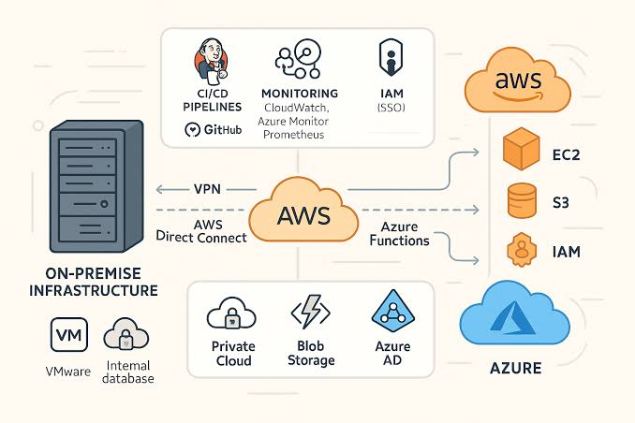
8.2 Recommended architecture components
User access and traffic control: Students, staff and approved college users connect through browsers or mobile apps. A secure internet entry point can include DNS, a web application firewall and a load balancer. The firewall filters unwanted requests, while the load balancer directs valid traffic to available application instances.
Application and API layer: Applications such as the SIS, LMS, library, exam portal and email can use different service models according to their needs. An API gateway should provide controlled access to functions used by the mobile app and partner colleges. It can validate credentials, enforce permissions, apply rate limits and log requests.
Data and storage layer: Student records, course data, library information, documents and backups should be stored in appropriate managed databases or storage services. Applications should access only the data they need. Payment processing should connect to an approved payment provider and avoid exposing sensitive payment information to college systems.
Identity, monitoring and recovery: Central identity management can support consistent account policies. Staff accounts should receive stronger protection, such as multi-factor authentication. Monitoring should capture service health, errors and unusual access. Backups and recovery copies should be stored separately from the primary service, and restoration should be practised.
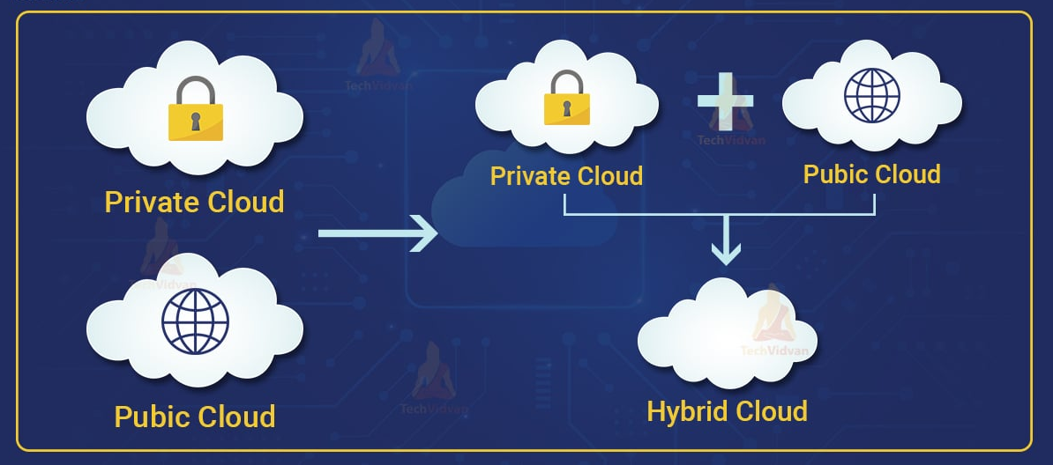
8.3 How the design addresses the scenario
The load balancer and application tier can spread requests across multiple instances. During admissions or exams, the university can add application capacity and reduce it afterwards, subject to cost controls and testing. The API gateway provides the mobile app and colleges with defined interfaces without granting direct database access.
The hybrid connection provides flexibility for sensitive or legacy workloads, but it adds network and management complexity. The university should document which systems live in each environment, how they communicate and which team responds when a connection fails.
8.4 Sizing and availability
The current figures—12 servers at around 15% average CPU use with peaks above 95%—are useful for identifying inefficiency, but they are not enough to size the cloud architecture. The university should collect application-level metrics such as requests per second, response times, database load, memory, storage growth and network traffic during real peak periods.
Availability depends on the full service path. A resilient application tier will not meet the university’s target if its database, identity provider, internet connection or payment service becomes unavailable. The university should define availability measurements, test failure scenarios and verify recovery procedures before committing to a production design.

Task 9 — Hands-on Implementation and Documentation
9.1 Purpose and scope of the prototype
A small prototype can show how a university application might expose a function through a web API, package it in a container and deploy it to a cloud platform. For example, a Flask service can return sample student results for a test identifier. This demonstrates basic implementation steps; it does not prove that the full SIS is secure, scalable or suitable for production.
Use synthetic data, not real student records, in the prototype. If the assignment requires screenshots, they should show the student’s own execution and environment.
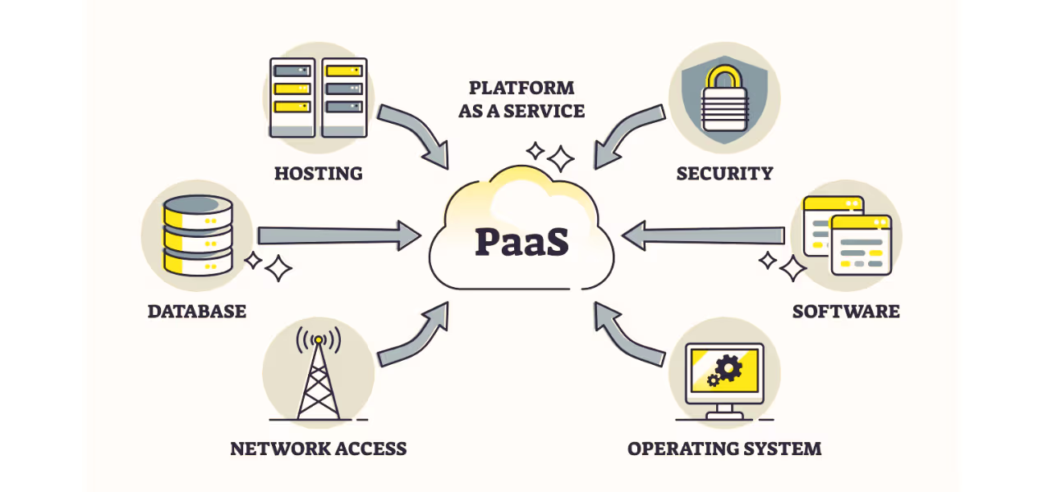
9.2 Example API behaviour
A basic endpoint might return results for a test student and a not-found response for any other identifier:
from flask import Flask, jsonify
app = Flask(__name__)
@app.get("/api/v1/students/<student_id>/results")
def results(student_id):
if student_id != "S12345":
return jsonify({"error": "Student not found"}), 404

return jsonify({
"studentId": student_id,
"semester": "2026S1",
"results": [{"course": "CSA15", "grade": "A"}]
})
This example illustrates request routing and JSON responses. It omits authentication, authorisation and a real database, so it should be described as a learning prototype rather than a completed student-record service.
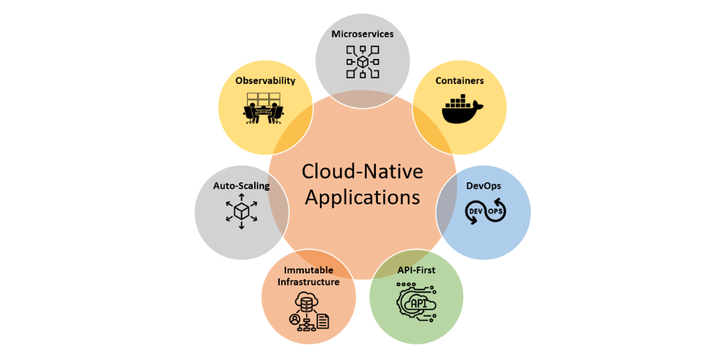
9.3 Container and cloud deployment evidence
The Dockerfile should specify the application environment and how it starts. The report should give the actual build and run commands used, the platform selected for deployment, and any configuration required. If the service is deployed to a PaaS, explain what the platform manages and what the developer still manages.
Document the endpoint, test inputs and observed output. Include a successful response and a failure case such as an unknown student returning HTTP 404. If a deployment or test was not actually run, label the output as expected rather than presenting it as evidence.
9.4 Security and reproducibility
Before deployment, add user authentication, check permissions for each requested record, validate inputs and use HTTPS. Do not include passwords or API keys in source code or screenshots. Avoid logging student data and use least privilege for database access.
Record the software versions and steps needed to reproduce the build. A working container demonstrates that the service can run in a packaged environment; production readiness would additionally require performance testing, recovery testing, security review and operational monitoring.
Task 10 — Evaluate and Recommend the Final Solution
10.1 Options for the university
Retain the current on-premise setup: This avoids immediate migration work and gives the university direct control of its servers. However, it leaves the current problems in place: low average utilisation, slow server procurement, insufficient peak capacity and no disaster recovery site.
Move all systems to public cloud: This can make capacity available more quickly and may reduce the need to operate physical servers. It could also require significant application changes, migration effort, new operational skills and careful management of recurring usage costs.
Adopt a hybrid design: The university can move suitable services first and keep selected workloads in a connected private environment while it assesses legacy compatibility and data requirements. This makes migration more gradual, although the university must operate and secure connections across both environments.
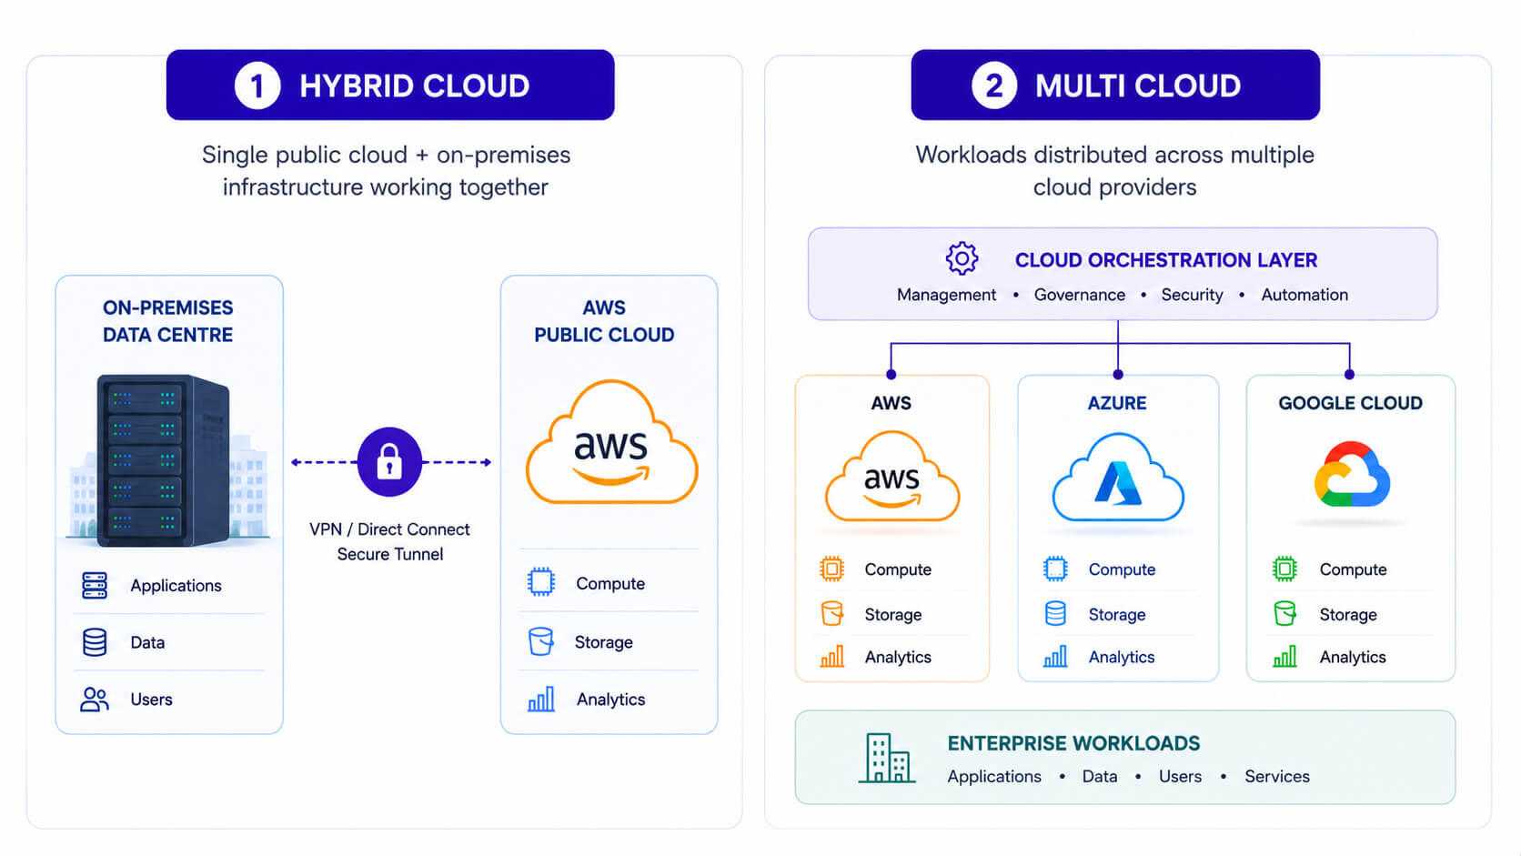
10.2 Three-year cost comparison
The assignment does not provide server purchase prices, provider rates, data volumes, licence costs, staffing costs or migration estimates. Therefore, a defensible three-year cost total cannot be calculated from the given information alone. The university should collect those figures and compare the same workload and availability assumptions across all options.
Include in the estimate | Questions to answer
Infrastructure | What are the costs of servers, storage, network, power and facilities, or cloud compute and storage?
Operations | What staff time is needed for patching, monitoring, support and security?
Migration | What will application assessment, data transfer, integration and training cost?
Availability and recovery | What capacity, backup, replication and recovery services are required?
Usage and licensing | How do peak periods, network transfer, software licences and support plans affect charges?
Use a three-year total that includes both one-time migration costs and recurring operations. State assumptions, include peak-period use, and test different demand scenarios. Compare the cost of equivalent service levels; a low-cost design that cannot meet exam-period demand or recovery needs is not an equivalent option.
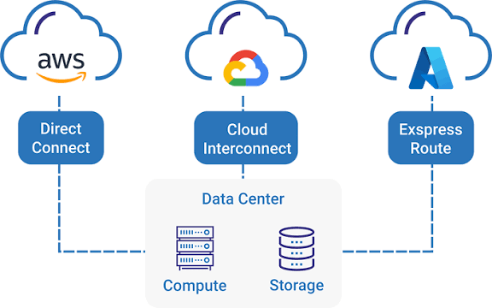
10.3 Recommendation and phased plan
A phased hybrid migration is a reasonable initial recommendation. Begin with an inventory of applications, dependencies, data sensitivity and usage patterns. Move a lower-risk service or development environment first, then review its cost, performance and operational impact. Next, migrate suitable SaaS services and modernise selected application interfaces. Migrate core student systems only after compatibility, security, recovery and user acceptance have been assessed.
This sequence lets the university learn from early migrations and reduce the risk of a disruptive all-at-once change. The recommendation should be revisited after the university collects actual cost and workload data.

Task 11 — Re-evaluate and Adapt the Design
11.1 Impact Analysis
The original scenario involved about 25,000 students and 2,000 staff using university systems across four campuses. The Day-4 change adds a mobile app and access for 40 affiliated colleges, raises expected demand to ten times the current peak, sets a 99.9% availability target and keeps the operating budget limited.
This affects the original assumptions in four ways:
- Load: Average utilisation is no longer enough to size the service. The university must test peak transactions and the ten-times-peak target.
- Users and access: The design must support college systems and mobile clients as well as university users.
- Availability: A service that works in one region may still be unavailable if that region or a shared dependency fails.
- Cost: Capacity for ten-times-peak demand can become expensive if it is left running continuously.
Web services and APIs become critical because mobile apps and college systems need defined, controlled interfaces to university functions. The API gateway should authenticate callers and enforce permissions. Each college must be treated as a separate tenant: credentials, records and access rights should be isolated so one college cannot read or change another college’s data.
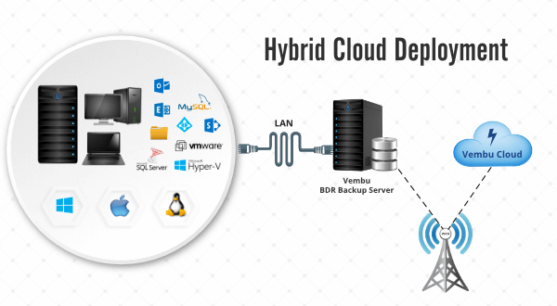
11.2 Evaluation of the Original Design
The original hybrid-cloud direction is still useful, but its service model mix and capacity plan need review.
IaaS virtual machines can preserve legacy SIS and exam applications, but simply adding VMs does not guarantee a ten-times increase in throughput. The database, application code, network or licensing limits may become bottlenecks. PaaS can reduce infrastructure work for modernised services and provide managed scaling. SaaS remains suitable for services such as email or an LMS where the provider’s features and data terms meet university requirements.
Auto-scaling can help the application tier handle changing demand, but it must be configured and tested against realistic load patterns. A single-region deployment has a regional failure risk; auto-scaling within that region cannot recover from a full-region outage. The 99.9% target allows roughly 8.76 hours of downtime in a 365-day year, so the university must measure availability across the full service path, including identity, database, network and payment dependencies.
Cost also needs reassessment. Capacity for ten-times-peak traffic could increase charges, especially if resources remain active outside peak periods or generate high data-transfer costs. The university should compare timed scaling, usage alerts and budgets against the cost of reserved capacity and recovery services.
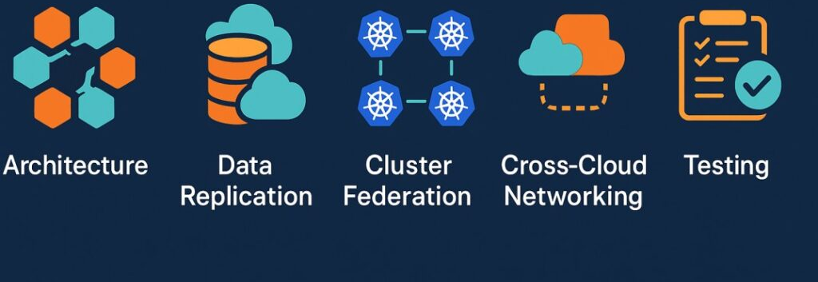
11.3 Adaptation or Redesign
Decision: modify the original design. Keep the hybrid approach for legacy and sensitive workloads, but redesign the external access and scale-out portions.
The revised design should include:
- An API gateway for the mobile app and college integrations, with authentication, per-college permissions, rate limits and audit logs.
- A multi-zone application tier that can add instances during peaks and continue serving requests if one availability zone fails.
- Container orchestration or managed PaaS for modern services that need independent deployment and scaling. Keep legacy applications on VMs until they are ready to be modernised.
- Managed database capabilities with tested backup and recovery. Evaluate database scaling limits and failover behaviour under load.
- Serverless functions only for suitable event-driven tasks, such as notifications, after checking execution limits, cost and provider dependence.
- A separate recovery plan, including backups and restoration exercises. Multi-zone deployment helps with local failures; it does not replace regional recovery.
This changes the mix from a VM-centred migration to a mixed design: VMs for compatible legacy systems, PaaS or containers for scalable application services, SaaS for appropriate standard applications, and selected XaaS such as managed databases and disaster recovery.
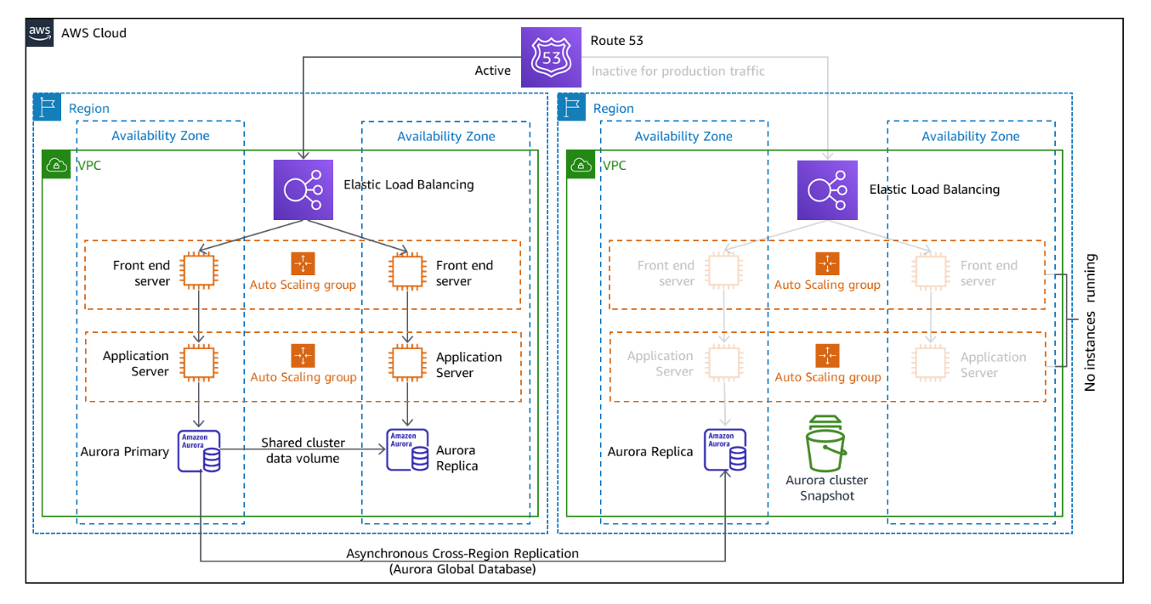
11.4 Evidence-Based Defence
Capacity calculation: The assignment gives a target of ten times current peak but not the measured peak request rate or resource usage. Therefore, an exact server count cannot be calculated responsibly from the supplied information. Define the measured current peak as P requests per second. The design test target is then:
Required tested throughput = 10 × P requests per second
Run load tests at that rate and observe application response time, error rate, database connections, CPU, memory and network use. Add capacity only where measurements show a bottleneck.
Availability calculation: 99.9% availability over 365 days gives:
365 × 24 × 60 × 0.001 = 525.6 minutes, or about 8 hours 46 minutes of annual downtime.
This is the total budget for unavailability across the service, so failures in dependencies count too. Multi-zone deployment, health checks, failover and tested backups help reduce risk, but actual availability must be measured and validated.
Comparison | Original design | Revised design
Scaling | Cloud capacity and virtual machines, with limited evidence for the new peak | Load-tested target of 10× peak; scale application instances based on measured demand
Availability | Hybrid cloud, potentially dependent on a single region | Multi-zone service design plus separate recovery procedures
College access | General web services | API gateway with separate credentials, permissions, rate limits and audit logs per college
Cost controls | Usage measured, but new demand uncertain | Budgets, alerts, timed scaling and load tests to estimate peak and normal-period costs
The revised design improves isolation and resilience, but adds integration and operational complexity. Containers, managed databases and cloud APIs can increase provider dependence, so the university should document export and recovery options. A phased rollout with performance tests and a pilot college can validate capacity, cost and access controls before all 40 colleges are connected.

